Computer Networks

Lab Task #3

Saad Ahmad

20P-0051

Task 1

First add 4 PC and add one switch.

Connect the PCs with switch using straight through cable.

Then assign the IPs to the devices using the Class C IPs and private IPs.

Like

**PC1:** 192.168.1.1 and **subnet mask**: 255.255.255.0

**PC2:** 192.168.1.2 and **subnet mask**: 255.255.255.0

**PC3:** 192.168.1.3 and **subnet mask:** 255.255.255.0

**PC4:** 192.168.1.4 and **subnet mask:** 255.255.255.0

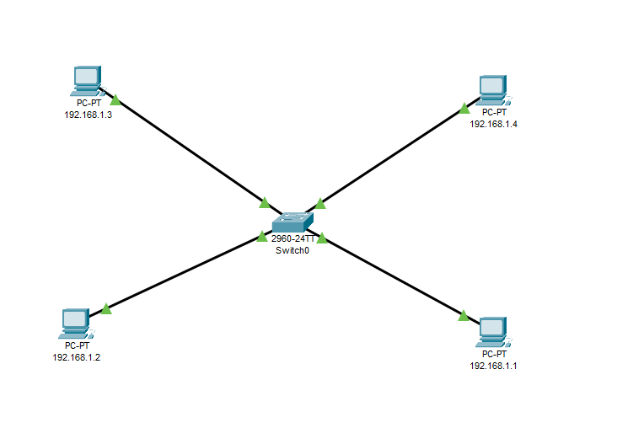

Result:



Task 2

First add 4 PC and add two switches.

Connect the first 2-PCs with switch 01 and other 2-PCs with switch 02 using straight through cable and then connect the 2-switcher using cross cable.

Then assign the IPs to the devices using the Class C IPs and private IPs.

Like

**PC1:** 192.168.1.1 and **subnet mask**: 255.255.255.0

**PC2:** 192.168.1.2 and **subnet mask**: 255.255.255.0

**PC3:** 192.168.1.3 and **subnet mask:** 255.255.255.0

**PC4:** 192.168.1.4 and **subnet mask:** 255.255.255.0

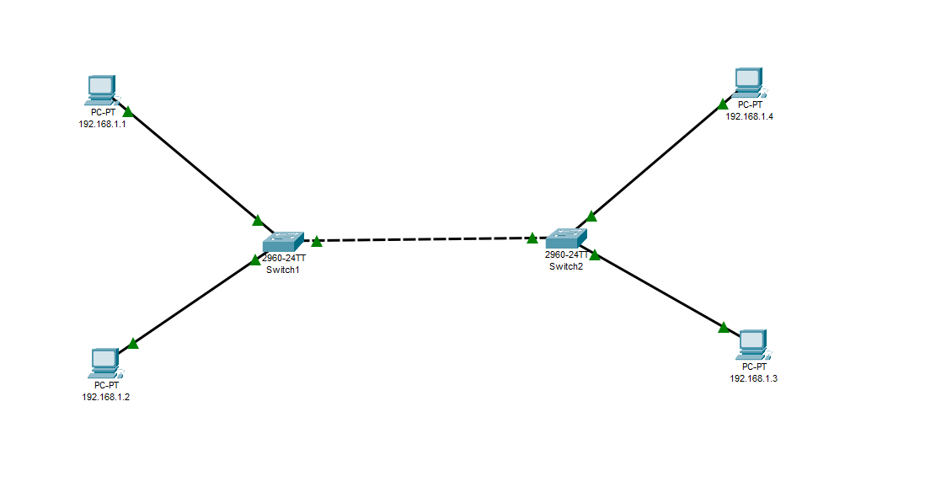

**Result:**



**Routers:**

**Task 1**

First add 4 PC, two switches and one router.

Connect the first 2-PCs with switch 01 and then connect the switch 01 with one end of the router and similarly connect other 2-PCs with switch 02 and then connect the switch 02 with the other end of the router.

Then assign the IPs to the devices using the Class C IPs and private IPs and set the gateways.

Like

**PC1:** 192.168.1.1 and **subnet mask**: 255.255.255.0 and **gateway:** 192.168.1.10

**PC2:** 192.168.1.2 and **subnet mask**: 255.255.255.0 and **gateway:** 192.168.1.10

**PC3:** 192.168.1.3 and **subnet mask:** 255.255.255.0 and **gateway:** 192.168.2.10

**PC4:** 192.168.1.4 and **subnet mask:** 255.255.255.0 and **gateway:** 192.168.2.10

Configuring the router:

**Gigabit Ethernet 0/0**: 192.168.1.10

**Gigabit Ethernet 0/1**: 192.168.2.10

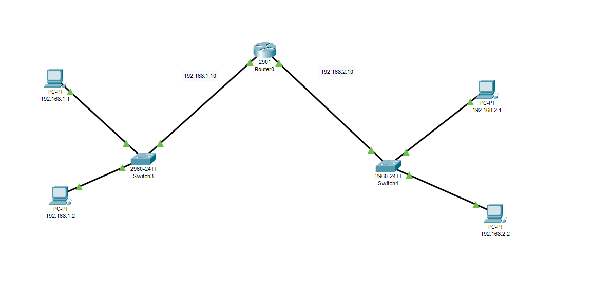

**Result:**

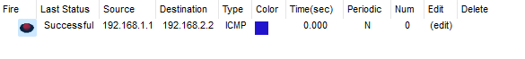

**Task 2**

First add 4 PC, two switches and two routers.

Connect the first 2-PCs with switch 01 and then connect the switch one with one end of the router and similarly connect other 2-PCs with switch 02 and then connect the switch two with the other end of the router but now we have to connect the two routers using the cross cable.

Then assign the IPs to the devices using the Class C IPs and private IPs and the gateways.

Like

**PC1:** 192.168.1.1 and **subnet mask**: 255.255.255.0 and **gateway:** 192.168.1.10

**PC2:** 192.168.1.2 and **subnet mask**: 255.255.255.0 and **gateway:** 192.168.1.10

**PC3:** 192.168.1.3 and **subnet mask:** 255.255.255.0 and **gateway:** 192.168.2.10

**PC4:** 192.168.1.4 and **subnet mask:** 255.255.255.0 and **gateway:** 192.168.2.10

**Configuring the router 01:**

**Gigabit Ethernet 0/0**: 192.168.1.10

**Gigabit Ethernet 0/1**: 192.168.3.10

**Routing:**

**Network**: 192.168.2.0

**Mask**: 255.255.255.0

**Next** **Hop**: 192.168.3.11

**Configuring the router 02**:

**Gigabit Ethernet 0/0**: 192.168.2.10

**Gigabit Ethernet 0/1**: 192.168.3.11

**Routing:**

**Network**: 192.168.1.0

**Mask**: 255.255.255.0

**Next** **Hop**: 192.168.3.10

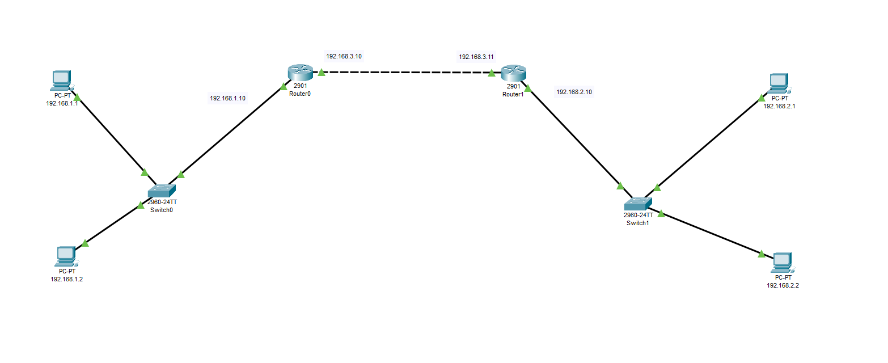

**Result:**



**Task 3**

First add 6 PC, 3 switches and 3 routers.

Connect the first 2-PCs with switch 01 and then connect the switch 01 with one end of the router 01 and similarly connect 2-PCs with switch 02 and then connect the switch 02 with the other end of the router 02 and similarly connect 2-PCs with switch 03 and then connect the switch 03 with the other end of the router 03 and now connect all the routers with themselves using cross cable.

Then assign the IPs to the devices using the Class C IPs and private IPs and the gateways.

Like

**PC1:** 192.168.1.1 and **subnet mask**: 255.255.255.0 and **gateway:** 192.168.1.10

**PC2:** 192.168.1.2 and **subnet mask**: 255.255.255.0 and **gateway:** 192.168.1.10

**PC3:** 192.168.2.1 and **subnet mask:** 255.255.255.0 and **gateway:** 192.168.2.10

**PC4:** 192.168.2.2 and **subnet mask:** 255.255.255.0 and **gateway:** 192.168.2.10

**PC5:** 192.168.3.1 and **subnet mask:** 255.255.255.0 and **gateway:** 192.168.3.10

**PC6:** 192.168.3.2 and **subnet mask:** 255.255.255.0 and **gateway:** 192.168.3.10

**Configuring the router 01:**

**Gigabit Ethernet 0/0**: 192.168.1.10

**Gigabit Ethernet 0/1**: 192.168.4.20

**Routing_1:**

**Network**: 192.168.2.0

**Mask**: 255.255.255.0

**Next** **Hop**: 192.168.4.22

**Routing_2:**

**Network**: 192.168.3.0

**Mask**: 255.255.255.0

**Next** **Hop**: 192.168.4.22

**Configuring the router 02:**

**Gigabit Ethernet 0/0**: 192.168.2.10

**Gigabit Ethernet 0/1**: 192.168.4.22

**Routing_1:**

**Network**: 192.168.1.0

**Mask**: 255.255.255.0

**Next** **Hop**: 192.168.4.20

**Routing_2:**

**Network**: 192.168.3.0

**Mask**: 255.255.255.0

**Next** **Hop**: 192.168.5.20

**Configuring the router 03:**

**Gigabit Ethernet 0/0**: 192.168.3.10

**Gigabit Ethernet 0/2**: 192.168.5.20

**Routing_1:**

**Network**: 192.168.2.0

**Mask**: 255.255.255.0

**Next** **Hop**: 192.168.5.22

**Routing_2:**

**Network**: 192.168.1.0

**Mask**: 255.255.255.0

**Next** **Hop**: 192.168.5.22

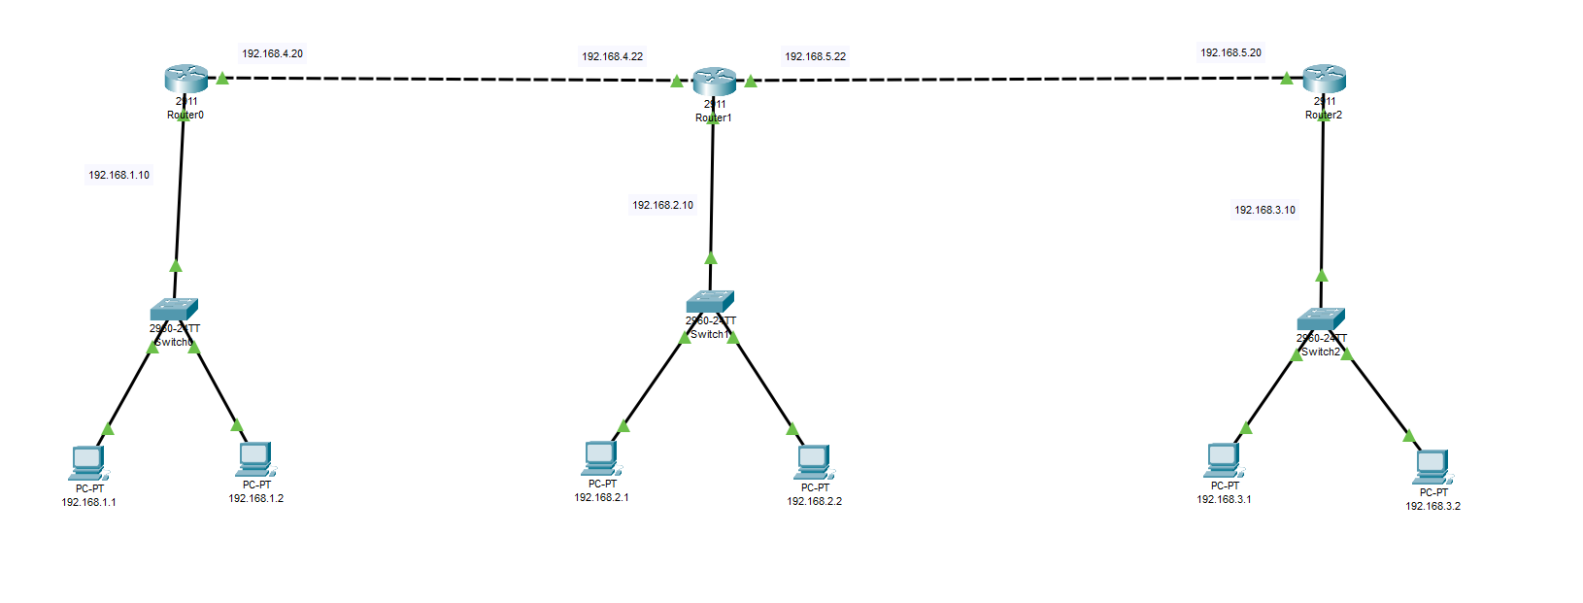

**Result:**

